SPCA Research
Colour Palette
Grey/ Light Blue:
- HEX - #e1e5ee
- RGB - rgba(225, 229, 238)
- HSL - 222, 28, 91 (Image Color Picker, 2026)
Green:
- HEX - #8ebc46
- RGB - rgba(142, 188, 70)
- HSL - 83, 47, 51 (Image Color Picker, 2026)
Blue:
- HEX - #1d2c59
- RGB - rgba(29, 44, 89)
- HSL - 225, 51, 23 (Image Color Picker, 2026)
Red:
- HEX - #a42037
- RGB - rgba(164, 32, 55)
- HSL - 350, 67, 38 (Image Color Picker, 2026)
Typography:
Simple Sans-Serif fonts such as Arial or Helvetica (Web.MIT, n.d.).

Homepage
Brief introduction:
- SPCA (Society of the Prevention of Cruelty to Animals) is a non-profit organisation
- Rescue, cares and protects animals
- Educates public on responsible pet ownership (Kids SPCA Education, 2026)
- Gives second chance to animals in need and provides safe homes
Variation of animals SPCA works with:
- Domestic pets - cats and dogs
- Farm animals - cattle, goats, sheep, pigs, horses
- Various wildlife species - bats, baboons, rabbits, raptors, porcupines, pigeons, seals, snakes (Cape of Good Hope SPCA, 2026)
Socials:
- Instagram - @capespca
- Facebook - @NSPCA
Emergency numbers:
- 021 700 4140 - local (SPCA Digital, 2021)
- 011 907 3590 - national (NSPCA, 2026)

About Us
Brief history:
- Started in England in 1824 (SPCA International, 2025)
- First opened in South Africa in 1872
- First animal hospital opened in 1920
- Evolved throughout 19th and 20th century to include pets, wildlife and farm animals
- Today offers veterinary, rescue and education services
Mission and Vision:
- Prevent cruelty and promote kindness towards animals through services offered
- Create a world where animals are treated with respect and are safe (SPCA International, 2026)
Focus Areas:
- Remove animals from neglect and abuse
- Educate communities on compassionate animal care
- Provide medical care and sterilization
- Uphold animal laws
- Ensure animals are fed and live freely without pain or fear (NSPCA, 2025)
Team members:
- CEO: Mqabuko Moyo Ndukwana - leads organisation
- Manager, Wildlife Unit: Megan Reid - specializes in protection, rescue and welfare of animals
- Animal Welfare Assistant: Keagan Wolfaardt - provides primary animal health care and assists in hospitals
- Chief Inspector: Jaco Pieterse - Oversees investigation in animal cruelty and enforces animal welfare laws (Cape of Good Hope SPCA, 2025)

Services
Adoption:
- Responsible individuals (18+) looking for a long-term commitment
- Provides animals with safe and loving homes
Steps to pursue action:
- Meet animal in person
- Complete application with ID and proof of residence
- Follow a home inspection
- Once everything is approved, sign contract and collect pet (Cape of Good Hope SPCA, 2025)
Donations:
- Open to anyone
- Covers costs of food, blankets, surgeries and maintenance of shelters
Steps to pursue action:
- Choose method of payment
- Select where money should flow towards (kennels, surgeries, etc.)
- If you have any items you are willing to donate such as clothes or toys, please drop off at nearest branch. (Cape of Good Hope SPCA, 2024)
Reports:
- Any person who witnesses animal abuse, neglect or endangerment
- Anyone who finds stray animals
- Help save the lives of animals
Steps to pursue action:
- Locate nearest branch
- Safely document scene with photos or videos and add exact time and address
- Contact local or national branch for emergencies. Send email for non-urgent records
- You can report confidentially and provide formal written statement (NSPCA, 2021)

Enquiry Form
- One form for selected purpose - adopt, report, become volunteer or sponsor
- Provide name, email, reason and message
- If you want to place an application for adoption or file a report, read service page to provide necessary information
- If you want to become a volunteer, you must state which activity you will help out with and attend a mandatory training session (Cape of Good Hope SPCA, 2026)
- Activities include: Dog walking, cat socialization, cleaning or fundraising
- If you want to become a sponsor (monthly donor), you must be at least 18 years of age and have a stable income. Complete the form with your contribution details

Contact Page
Cape Town Branch:
- Phone: 021 700 4140
- Email: info@capespca.co.za
- Address: 1st Ave &, First Rd, Grassy Park, Cape Town, 8000 (Cape of Good Hope SPCA, 2026)
Johannesburg Branch:
- Phone: 011 681 3600
- Email: pr@jhbspca.co.za
- Address: 5 Benray Rd, Reuven, Johannesburg, 2091 (Johannesburg SPCA, 2026)
Cases of Emergency:
- Contact the Cape of Good Hope SPCA 24-hour Inspectorate at 021 700 4158 for any injured or distressed animals
- Contact 083 326 1604 for after-hour emergencies (SPCA Digital, 2021)
- For national emergencies contact the NSPCA at 011 907 3590 (NSPCA, 2026)
- Do not use social media for immediate, life-threatening animal emergencies

Sitemap:
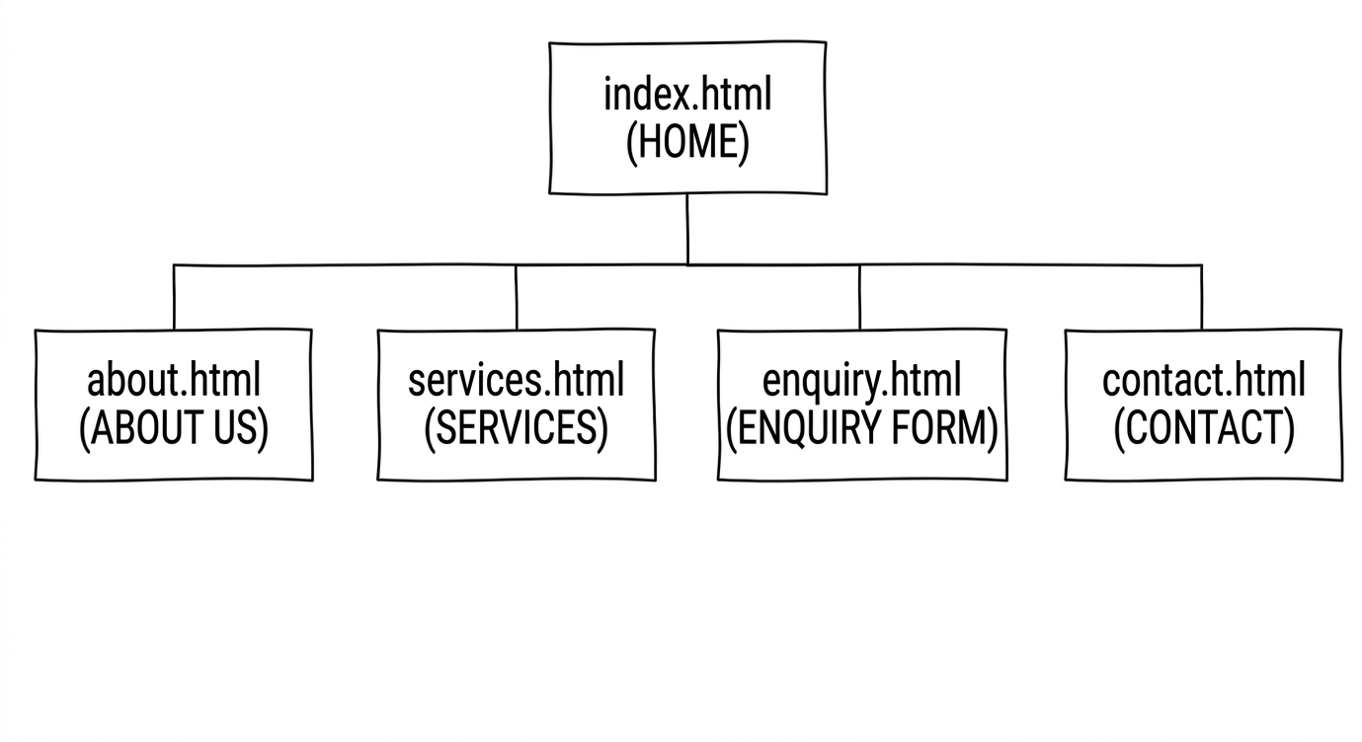
References:
- Cape of Good Hope SPCA. (2024) Donate. Available at: https://capespca.co.za/donate/ (Accessed: 19 April 2026).
- Cape of Good Hope SPCA. (2025) Adoptions. Available at: https://capespca.co.za/adopt/ (Accessed: 19 April 2026).
- Cape of Good Hope SPCA. (2025) Inspectorate Department. Available at: https://capespca.co.za/services/inspectorate-department/ (Accessed: 19 April 2026).
- Cape of Good Hope SPCA. (2026) Volunteer. Available at: https://capespca.co.za/get-involved/volunteer/ (Accessed: 19 April 2026).
- Cape of Good Hope SPCA. (2026) Welcome to the Cape of Good Hope SPCA. Available at: https://capespca.co.za/ (Accessed: 19 April 2026).
- Cape of Good Hope SPCA. (2026) Wildlife. Available at: https://capespca.co.za/services/wildlife/ (Accessed: 19 April 2026).
- FontIcon. (2026) Vector icons for navigation and service categories. Available at: https://fontawesome.com (Accessed: 20 April 2026). -Image Folder Reference
- Image Color Picker. (2026) Color picker online | HEX color picker | HTML color picker. Available at: https://imagecolorpicker.com/ (Accessed: 19 April 2026).
- Johannesburg SPCA. (2026) Contact us. Available at: https://jhbspca.co.za/contact-us/ (Accessed: 19 April 2026).
- Kids SPCA Education. (2026) What we do. Available at: https://kids.spcaeducation.org.nz/about-spca/what-we-do/ (Accessed: 19 April 2026).
- NSPCA. (2021) SAPS guide: Animal Protection Act. Available at: https://nspca.co.za/wp-content/uploads/2021/11/SAPS-Guide.pdf (Accessed: 19 April 2026).
- NSPCA. (2025) About the NSPCA. Available at: https://nspca.co.za/about-us/ (Accessed: 19 April 2026).
- NSPCA. (2026) Contact the National Council of SPCAs in South Africa. Available at: https://nspca.co.za/contact/ (Accessed: 19 April 2026).
- SPCA Digital. (2021) How can I help? Emergency response information. Available at: https://capespca.co.za/wildlife-news/how-can-i-help-emergency-response-information/ (Accessed: 19 April 2026).
- SPCA International. (2025) Our history. Available at: https://www.spcai.org/about (Accessed: 19 April 2026).
- SPCA International. (2026) Mission, vision & values. Available at: https://www.spcai.org/about/mission-vision-values (Accessed: 19 April 2026).
- Unsplash. (2026) Stock photography for animal welfare and staff profiles. Available at: https://unsplash.com (Accessed: 20 April 2026). -Image Folder Reference
- Web.MIT. (n.d.) Safe web fonts. Available at: https://web.mit.edu/jmorzins/www/fonts.html (Accessed: 19 April 2026).

